Noor blum

Design Assignment DA6

**DO NOT REMOVE THIS PAGE DURING SUBMISSION:**

The student understands that all required components should be submitted in complete for grading of this assignment.

|  |  |  |  |
| --- | --- | --- | --- |
| **NO** | **SUBMISSION ITEM** | **COMPLETED (Y/N)** | **MARKS**  **(/MAX)** |
| 0. | C CODE WITH COMMENTS FOR TASK | Y |  |
| 1. | SCHEMATIC | Y |  |
| 2. | Flow Chart | Y |  |
| 3. | SNAPSHOT OF THE BOARD WITH CONNECTED COMPONENTS | Y |  |
| 4. | SNAPSHOT OF THE COMPUTER SCREEN WITH TERMINAL | Y |  |
| 5. | YouTube Video Link | Y |  |

|  |  |  |  |
| --- | --- | --- | --- |
| 0. | C CODE WITH COMMENTS FOR TASK |  |  |

#ifndef F_CPU

#define F_CPU 1600000UL

#endif

#include <avr/io.h>

#include <util/delay.h>

#include "lcd.h"

void adc_init()

{

ADMUX = (1<<REFS0);

ADCSRA = (1<<ADEN);

}

// read adc value

uint16_t adc_read(uint8_t ch)

{

ch &= 0b00000111; // AND operation with 7

ADMUX = (ADMUX & 0xF7)|ch;

ADCSRA |= (1<<ADSC);

while(ADCSRA & (1<<ADSC));

return (ADC);

}

int main()

{

uint16_t adc_result0;

int temp;

char buffer[10];

// initialize adc and lcd

adc_init();

lcd_init(LCD_DISP_ON_CURSOR);

lcd_clrscr();

lcd_gotoxy(0,0);

_delay_ms(50);

while(1)

{

adc_result0 = adc_read(0);// read adc value at PC0

temp=adc_result0/16.0; // finding the temperature

lcd_gotoxy(0,0);

itoa(temp,buffer,10);

lcd_puts("Temperature="); //display temperature

lcd_puts(buffer);

lcd_puts(" "); //display temperature

lcd_puts(" "); //display temperature

lcd_gotoxy(0,1);

lcd_puts(" "); //display temperature

lcd_puts("By Noor Blum ");//display temperature

_delay_ms(500);

}

}

/****************************************************************************

Title : HD44780U LCD library

Author: Peter Fleury <pfleury@gmx.ch> http://jump.to/fleury

File: $Id: lcd.c,v 1.14.2.2 2012/02/12 07:51:00 peter Exp $

Software: AVR-GCC 3.3

Target: any AVR device, memory mapped mode only for AT90S4414/8515/Mega

DESCRIPTION

Basic routines for interfacing a HD44780U-based text lcd display

Originally based on Volker Oth's lcd library,

changed lcd_init(), added additional constants for lcd_command(),

added 4-bit I/O mode, improved and optimized code.

Library can be operated in memory mapped mode (LCD_IO_MODE=0) or in

4-bit IO port mode (LCD_IO_MODE=1). 8-bit IO port mode not supported.

Memory mapped mode compatible with Kanda STK200, but supports also

generation of R/W signal through A8 address line.

USAGE

See the C include lcd.h file for a description of each function

*****************************************************************************/

#include <inttypes.h>

#include <avr/io.h>

#include <avr/pgmspace.h>

#include "lcd.h"

/*

** constants/macros

*/

#define DDR(x) (*(&x - 1)) /* address of data direction register of port x */

#if defined(__AVR_ATmega64__) || defined(__AVR_ATmega128__)

/* on ATmega64/128 PINF is on port 0x00 and not 0x60 */

#define PIN(x) ( &PORTF==&(x) ? _SFR_IO8(0x00) : (*(&x - 2)) )

#else

#define PIN(x) (*(&x - 2)) /* address of input register of port x */

#endif

#if LCD_IO_MODE

#define lcd_e_delay() __asm__ __volatile__( "rjmp 1f\n 1:" ); //#define lcd_e_delay() __asm__ __volatile__( "rjmp 1f\n 1: rjmp 2f\n 2:" );

#define lcd_e_high() LCD_E_PORT |= _BV(LCD_E_PIN);

#define lcd_e_low() LCD_E_PORT &= ~_BV(LCD_E_PIN);

#define lcd_e_toggle() toggle_e()

#define lcd_rw_high() LCD_RW_PORT |= _BV(LCD_RW_PIN)

#define lcd_rw_low() LCD_RW_PORT &= ~_BV(LCD_RW_PIN)

#define lcd_rs_high() LCD_RS_PORT |= _BV(LCD_RS_PIN)

#define lcd_rs_low() LCD_RS_PORT &= ~_BV(LCD_RS_PIN)

#endif

#if LCD_IO_MODE

#if LCD_LINES==1

#define LCD_FUNCTION_DEFAULT LCD_FUNCTION_4BIT_1LINE

#else

#define LCD_FUNCTION_DEFAULT LCD_FUNCTION_4BIT_2LINES

#endif

#else

#if LCD_LINES==1

#define LCD_FUNCTION_DEFAULT LCD_FUNCTION_8BIT_1LINE

#else

#define LCD_FUNCTION_DEFAULT LCD_FUNCTION_8BIT_2LINES

#endif

#endif

#if LCD_CONTROLLER_KS0073

#if LCD_LINES==4

#define KS0073_EXTENDED_FUNCTION_REGISTER_ON 0x2C /* |0|010|1100 4-bit mode, extension-bit RE = 1 */

#define KS0073_EXTENDED_FUNCTION_REGISTER_OFF 0x28 /* |0|010|1000 4-bit mode, extension-bit RE = 0 */

#define KS0073_4LINES_MODE 0x09 /* |0|000|1001 4 lines mode */

#endif

#endif

/*

** function prototypes

*/

#if LCD_IO_MODE

static void toggle_e(void);

#endif

/*

** local functions

*/

/*************************************************************************

delay loop for small accurate delays: 16-bit counter, 4 cycles/loop

*************************************************************************/

static inline void _delayFourCycles(unsigned int __count)

{

if ( __count == 0 )

__asm__ __volatile__( "rjmp 1f\n 1:" ); // 2 cycles

else

__asm__ __volatile__ (

"1: sbiw %0,1" "\n\t"

"brne 1b" // 4 cycles/loop

: "=w" (__count)

: "0" (__count)

);

}

/*************************************************************************

delay for a minimum of <us> microseconds

the number of loops is calculated at compile-time from MCU clock frequency

*************************************************************************/

#define delay(us) _delayFourCycles( ( ( 1*(XTAL/4000) )*us)/1000 )

#if LCD_IO_MODE

/* toggle Enable Pin to initiate write */

static void toggle_e(void)

{

lcd_e_high();

lcd_e_delay();

lcd_e_low();

}

#endif

/*************************************************************************

Low-level function to write byte to LCD controller

Input: data byte to write to LCD

rs 1: write data

0: write instruction

Returns: none

*************************************************************************/

#if LCD_IO_MODE

static void lcd_write(uint8_t data,uint8_t rs)

{

unsigned char dataBits ;

if (rs) { /* write data (RS=1, RW=0) */

lcd_rs_high();

} else { /* write instruction (RS=0, RW=0) */

lcd_rs_low();

}

lcd_rw_low();

if ( ( &LCD_DATA0_PORT == &LCD_DATA1_PORT) && ( &LCD_DATA1_PORT == &LCD_DATA2_PORT ) && ( &LCD_DATA2_PORT == &LCD_DATA3_PORT )

&& (LCD_DATA0_PIN == 0) && (LCD_DATA1_PIN == 1) && (LCD_DATA2_PIN == 2) && (LCD_DATA3_PIN == 3) )

{

/* configure data pins as output */

DDR(LCD_DATA0_PORT) |= 0x0F;

/* output high nibble first */

dataBits = LCD_DATA0_PORT & 0xF0;

LCD_DATA0_PORT = dataBits |((data>>4)&0x0F);

lcd_e_toggle();

/* output low nibble */

LCD_DATA0_PORT = dataBits | (data&0x0F);

lcd_e_toggle();

/* all data pins high (inactive) */

LCD_DATA0_PORT = dataBits | 0x0F;

}

else

{

/* configure data pins as output */

DDR(LCD_DATA0_PORT) |= _BV(LCD_DATA0_PIN);

DDR(LCD_DATA1_PORT) |= _BV(LCD_DATA1_PIN);

DDR(LCD_DATA2_PORT) |= _BV(LCD_DATA2_PIN);

DDR(LCD_DATA3_PORT) |= _BV(LCD_DATA3_PIN);

/* output high nibble first */

LCD_DATA3_PORT &= ~_BV(LCD_DATA3_PIN);

LCD_DATA2_PORT &= ~_BV(LCD_DATA2_PIN);

LCD_DATA1_PORT &= ~_BV(LCD_DATA1_PIN);

LCD_DATA0_PORT &= ~_BV(LCD_DATA0_PIN);

if(data & 0x80) LCD_DATA3_PORT |= _BV(LCD_DATA3_PIN);

if(data & 0x40) LCD_DATA2_PORT |= _BV(LCD_DATA2_PIN);

if(data & 0x20) LCD_DATA1_PORT |= _BV(LCD_DATA1_PIN);

if(data & 0x10) LCD_DATA0_PORT |= _BV(LCD_DATA0_PIN);

lcd_e_toggle();

/* output low nibble */

LCD_DATA3_PORT &= ~_BV(LCD_DATA3_PIN);

LCD_DATA2_PORT &= ~_BV(LCD_DATA2_PIN);

LCD_DATA1_PORT &= ~_BV(LCD_DATA1_PIN);

LCD_DATA0_PORT &= ~_BV(LCD_DATA0_PIN);

if(data & 0x08) LCD_DATA3_PORT |= _BV(LCD_DATA3_PIN);

if(data & 0x04) LCD_DATA2_PORT |= _BV(LCD_DATA2_PIN);

if(data & 0x02) LCD_DATA1_PORT |= _BV(LCD_DATA1_PIN);

if(data & 0x01) LCD_DATA0_PORT |= _BV(LCD_DATA0_PIN);

lcd_e_toggle();

/* all data pins high (inactive) */

LCD_DATA0_PORT |= _BV(LCD_DATA0_PIN);

LCD_DATA1_PORT |= _BV(LCD_DATA1_PIN);

LCD_DATA2_PORT |= _BV(LCD_DATA2_PIN);

LCD_DATA3_PORT |= _BV(LCD_DATA3_PIN);

}

}

#else

#define lcd_write(d,rs) if (rs) *(volatile uint8_t*)(LCD_IO_DATA) = d; else *(volatile uint8_t*)(LCD_IO_FUNCTION) = d;

/* rs==0 -> write instruction to LCD_IO_FUNCTION */

/* rs==1 -> write data to LCD_IO_DATA */

#endif

/*************************************************************************

Low-level function to read byte from LCD controller

Input: rs 1: read data

0: read busy flag / address counter

Returns: byte read from LCD controller

*************************************************************************/

#if LCD_IO_MODE

static uint8_t lcd_read(uint8_t rs)

{

uint8_t data;

if (rs)

lcd_rs_high(); /* RS=1: read data */

else

lcd_rs_low(); /* RS=0: read busy flag */

lcd_rw_high(); /* RW=1 read mode */

if ( ( &LCD_DATA0_PORT == &LCD_DATA1_PORT) && ( &LCD_DATA1_PORT == &LCD_DATA2_PORT ) && ( &LCD_DATA2_PORT == &LCD_DATA3_PORT )

&& ( LCD_DATA0_PIN == 0 )&& (LCD_DATA1_PIN == 1) && (LCD_DATA2_PIN == 2) && (LCD_DATA3_PIN == 3) )

{

DDR(LCD_DATA0_PORT) &= 0xF0; /* configure data pins as input */

lcd_e_high();

lcd_e_delay();

data = PIN(LCD_DATA0_PORT) << 4; /* read high nibble first */

lcd_e_low();

lcd_e_delay(); /* Enable 500ns low */

lcd_e_high();

lcd_e_delay();

data |= PIN(LCD_DATA0_PORT)&0x0F; /* read low nibble */

lcd_e_low();

}

else

{

/* configure data pins as input */

DDR(LCD_DATA0_PORT) &= ~_BV(LCD_DATA0_PIN);

DDR(LCD_DATA1_PORT) &= ~_BV(LCD_DATA1_PIN);

DDR(LCD_DATA2_PORT) &= ~_BV(LCD_DATA2_PIN);

DDR(LCD_DATA3_PORT) &= ~_BV(LCD_DATA3_PIN);

/* read high nibble first */

lcd_e_high();

lcd_e_delay();

data = 0;

if ( PIN(LCD_DATA0_PORT) & _BV(LCD_DATA0_PIN) ) data |= 0x10;

if ( PIN(LCD_DATA1_PORT) & _BV(LCD_DATA1_PIN) ) data |= 0x20;

if ( PIN(LCD_DATA2_PORT) & _BV(LCD_DATA2_PIN) ) data |= 0x40;

if ( PIN(LCD_DATA3_PORT) & _BV(LCD_DATA3_PIN) ) data |= 0x80;

lcd_e_low();

lcd_e_delay(); /* Enable 500ns low */

/* read low nibble */

lcd_e_high();

lcd_e_delay();

if ( PIN(LCD_DATA0_PORT) & _BV(LCD_DATA0_PIN) ) data |= 0x01;

if ( PIN(LCD_DATA1_PORT) & _BV(LCD_DATA1_PIN) ) data |= 0x02;

if ( PIN(LCD_DATA2_PORT) & _BV(LCD_DATA2_PIN) ) data |= 0x04;

if ( PIN(LCD_DATA3_PORT) & _BV(LCD_DATA3_PIN) ) data |= 0x08;

lcd_e_low();

}

return data;

}

#else

#define lcd_read(rs) (rs) ? *(volatile uint8_t*)(LCD_IO_DATA+LCD_IO_READ) : *(volatile uint8_t*)(LCD_IO_FUNCTION+LCD_IO_READ)

/* rs==0 -> read instruction from LCD_IO_FUNCTION */

/* rs==1 -> read data from LCD_IO_DATA */

#endif

/*************************************************************************

loops while lcd is busy, returns address counter

*************************************************************************/

static uint8_t lcd_waitbusy(void)

{

register uint8_t c;

/* wait until busy flag is cleared */

while ( (c=lcd_read(0)) & (1<<LCD_BUSY)) {}

/* the address counter is updated 4us after the busy flag is cleared */

delay(2);

/* now read the address counter */

return (lcd_read(0)); // return address counter

}/* lcd_waitbusy */

/*************************************************************************

Move cursor to the start of next line or to the first line if the cursor

is already on the last line.

*************************************************************************/

static inline void lcd_newline(uint8_t pos)

{

register uint8_t addressCounter;

#if LCD_LINES==1

addressCounter = 0;

#endif

#if LCD_LINES==2

if ( pos < (LCD_START_LINE2) )

addressCounter = LCD_START_LINE2;

else

addressCounter = LCD_START_LINE1;

#endif

#if LCD_LINES==4

#if KS0073_4LINES_MODE

if ( pos < LCD_START_LINE2 )

addressCounter = LCD_START_LINE2;

else if ( (pos >= LCD_START_LINE2) && (pos < LCD_START_LINE3) )

addressCounter = LCD_START_LINE3;

else if ( (pos >= LCD_START_LINE3) && (pos < LCD_START_LINE4) )

addressCounter = LCD_START_LINE4;

else

addressCounter = LCD_START_LINE1;

#else

if ( pos < LCD_START_LINE3 )

addressCounter = LCD_START_LINE2;

else if ( (pos >= LCD_START_LINE2) && (pos < LCD_START_LINE4) )

addressCounter = LCD_START_LINE3;

else if ( (pos >= LCD_START_LINE3) && (pos < LCD_START_LINE2) )

addressCounter = LCD_START_LINE4;

else

addressCounter = LCD_START_LINE1;

#endif

#endif

lcd_command((1<<LCD_DDRAM)+addressCounter);

}/* lcd_newline */

/*

** PUBLIC FUNCTIONS

*/

/*************************************************************************

Send LCD controller instruction command

Input: instruction to send to LCD controller, see HD44780 data sheet

Returns: none

*************************************************************************/

void lcd_command(uint8_t cmd)

{

lcd_waitbusy();

lcd_write(cmd,0);

}

/*************************************************************************

Send data byte to LCD controller

Input: data to send to LCD controller, see HD44780 data sheet

Returns: none

*************************************************************************/

void lcd_data(uint8_t data)

{

lcd_waitbusy();

lcd_write(data,1);

}

/*************************************************************************

Set cursor to specified position

Input: x horizontal position (0: left most position)

y vertical position (0: first line)

Returns: none

*************************************************************************/

void lcd_gotoxy(uint8_t x, uint8_t y)

{

#if LCD_LINES==1

lcd_command((1<<LCD_DDRAM)+LCD_START_LINE1+x);

#endif

#if LCD_LINES==2

if ( y==0 )

lcd_command((1<<LCD_DDRAM)+LCD_START_LINE1+x);

else

lcd_command((1<<LCD_DDRAM)+LCD_START_LINE2+x);

#endif

#if LCD_LINES==4

if ( y==0 )

lcd_command((1<<LCD_DDRAM)+LCD_START_LINE1+x);

else if ( y==1)

lcd_command((1<<LCD_DDRAM)+LCD_START_LINE2+x);

else if ( y==2)

lcd_command((1<<LCD_DDRAM)+LCD_START_LINE3+x);

else /* y==3 */

lcd_command((1<<LCD_DDRAM)+LCD_START_LINE4+x);

#endif

}/* lcd_gotoxy */

/*************************************************************************

*************************************************************************/

int lcd_getxy(void)

{

return lcd_waitbusy();

}

/*************************************************************************

Clear display and set cursor to home position

*************************************************************************/

void lcd_clrscr(void)

{

lcd_command(1<<LCD_CLR);

}

/*************************************************************************

Set cursor to home position

*************************************************************************/

void lcd_home(void)

{

lcd_command(1<<LCD_HOME);

}

/*************************************************************************

Display character at current cursor position

Input: character to be displayed

Returns: none

*************************************************************************/

void lcd_putc(char c)

{

uint8_t pos;

pos = lcd_waitbusy(); // read busy-flag and address counter

if (c=='\n')

{

lcd_newline(pos);

}

else

{

#if LCD_WRAP_LINES==1

#if LCD_LINES==1

if ( pos == LCD_START_LINE1+LCD_DISP_LENGTH ) {

lcd_write((1<<LCD_DDRAM)+LCD_START_LINE1,0);

}

#elif LCD_LINES==2

if ( pos == LCD_START_LINE1+LCD_DISP_LENGTH ) {

lcd_write((1<<LCD_DDRAM)+LCD_START_LINE2,0);

}else if ( pos == LCD_START_LINE2+LCD_DISP_LENGTH ){

lcd_write((1<<LCD_DDRAM)+LCD_START_LINE1,0);

}

#elif LCD_LINES==4

if ( pos == LCD_START_LINE1+LCD_DISP_LENGTH ) {

lcd_write((1<<LCD_DDRAM)+LCD_START_LINE2,0);

}else if ( pos == LCD_START_LINE2+LCD_DISP_LENGTH ) {

lcd_write((1<<LCD_DDRAM)+LCD_START_LINE3,0);

}else if ( pos == LCD_START_LINE3+LCD_DISP_LENGTH ) {

lcd_write((1<<LCD_DDRAM)+LCD_START_LINE4,0);

}else if ( pos == LCD_START_LINE4+LCD_DISP_LENGTH ) {

lcd_write((1<<LCD_DDRAM)+LCD_START_LINE1,0);

}

#endif

lcd_waitbusy();

#endif

lcd_write(c, 1);

}

}/* lcd_putc */

/*************************************************************************

Display string without auto linefeed

Input: string to be displayed

Returns: none

*************************************************************************/

void lcd_puts(const char *s)

/* print string on lcd (no auto linefeed) */

{

register char c;

while ( (c = *s++) ) {

lcd_putc(c);

}

}/* lcd_puts */

/*************************************************************************

Display string from program memory without auto linefeed

Input: string from program memory be be displayed

Returns: none

*************************************************************************/

void lcd_puts_p(const char *progmem_s)

/* print string from program memory on lcd (no auto linefeed) */

{

register char c;

while ( (c = pgm_read_byte(progmem_s++)) ) {

lcd_putc(c);

}

}/* lcd_puts_p */

/*************************************************************************

Initialize display and select type of cursor

Input: dispAttr LCD_DISP_OFF display off

LCD_DISP_ON display on, cursor off

LCD_DISP_ON_CURSOR display on, cursor on

LCD_DISP_CURSOR_BLINK display on, cursor on flashing

Returns: none

*************************************************************************/

void lcd_init(uint8_t dispAttr)

{

#if LCD_IO_MODE

/*

* Initialize LCD to 4 bit I/O mode

*/

if ( ( &LCD_DATA0_PORT == &LCD_DATA1_PORT) && ( &LCD_DATA1_PORT == &LCD_DATA2_PORT ) && ( &LCD_DATA2_PORT == &LCD_DATA3_PORT )

&& ( &LCD_RS_PORT == &LCD_DATA0_PORT) && ( &LCD_RW_PORT == &LCD_DATA0_PORT) && (&LCD_E_PORT == &LCD_DATA0_PORT)

&& (LCD_DATA0_PIN == 0 ) && (LCD_DATA1_PIN == 1) && (LCD_DATA2_PIN == 2) && (LCD_DATA3_PIN == 3)

&& (LCD_RS_PIN == 4 ) && (LCD_RW_PIN == 5) && (LCD_E_PIN == 6 ) )

{

/* configure all port bits as output (all LCD lines on same port) */

DDR(LCD_DATA0_PORT) |= 0x7F;

}

else if ( ( &LCD_DATA0_PORT == &LCD_DATA1_PORT) && ( &LCD_DATA1_PORT == &LCD_DATA2_PORT ) && ( &LCD_DATA2_PORT == &LCD_DATA3_PORT )

&& (LCD_DATA0_PIN == 0 ) && (LCD_DATA1_PIN == 1) && (LCD_DATA2_PIN == 2) && (LCD_DATA3_PIN == 3) )

{

/* configure all port bits as output (all LCD data lines on same port, but control lines on different ports) */

DDR(LCD_DATA0_PORT) |= 0x0F;

DDR(LCD_RS_PORT) |= _BV(LCD_RS_PIN);

DDR(LCD_RW_PORT) |= _BV(LCD_RW_PIN);

DDR(LCD_E_PORT) |= _BV(LCD_E_PIN);

}

else

{

/* configure all port bits as output (LCD data and control lines on different ports */

DDR(LCD_RS_PORT) |= _BV(LCD_RS_PIN);

DDR(LCD_RW_PORT) |= _BV(LCD_RW_PIN);

DDR(LCD_E_PORT) |= _BV(LCD_E_PIN);

DDR(LCD_DATA0_PORT) |= _BV(LCD_DATA0_PIN);

DDR(LCD_DATA1_PORT) |= _BV(LCD_DATA1_PIN);

DDR(LCD_DATA2_PORT) |= _BV(LCD_DATA2_PIN);

DDR(LCD_DATA3_PORT) |= _BV(LCD_DATA3_PIN);

}

delay(16000); /* wait 16ms or more after power-on */

/* initial write to lcd is 8bit */

LCD_DATA1_PORT |= _BV(LCD_DATA1_PIN); // _BV(LCD_FUNCTION)>>4;

LCD_DATA0_PORT |= _BV(LCD_DATA0_PIN); // _BV(LCD_FUNCTION_8BIT)>>4;

lcd_e_toggle();

delay(4992); /* delay, busy flag can't be checked here */

/* repeat last command */

lcd_e_toggle();

delay(64); /* delay, busy flag can't be checked here */

/* repeat last command a third time */

lcd_e_toggle();

delay(64); /* delay, busy flag can't be checked here */

/* now configure for 4bit mode */

LCD_DATA0_PORT &= ~_BV(LCD_DATA0_PIN); // LCD_FUNCTION_4BIT_1LINE>>4

lcd_e_toggle();

delay(64); /* some displays need this additional delay */

/* from now the LCD only accepts 4 bit I/O, we can use lcd_command() */

#else

/*

* Initialize LCD to 8 bit memory mapped mode

*/

/* enable external SRAM (memory mapped lcd) and one wait state */

MCUCR = _BV(SRE) | _BV(SRW);

/* reset LCD */

delay(16000); /* wait 16ms after power-on */

lcd_write(LCD_FUNCTION_8BIT_1LINE,0); /* function set: 8bit interface */

delay(4992); /* wait 5ms */

lcd_write(LCD_FUNCTION_8BIT_1LINE,0); /* function set: 8bit interface */

delay(64); /* wait 64us */

lcd_write(LCD_FUNCTION_8BIT_1LINE,0); /* function set: 8bit interface */

delay(64); /* wait 64us */

#endif

#if KS0073_4LINES_MODE

/* Display with KS0073 controller requires special commands for enabling 4 line mode */

lcd_command(KS0073_EXTENDED_FUNCTION_REGISTER_ON);

lcd_command(KS0073_4LINES_MODE);

lcd_command(KS0073_EXTENDED_FUNCTION_REGISTER_OFF);

#else

lcd_command(LCD_FUNCTION_DEFAULT); /* function set: display lines */

#endif

lcd_command(LCD_DISP_OFF); /* display off */

lcd_clrscr(); /* display clear */

lcd_command(LCD_MODE_DEFAULT); /* set entry mode */

lcd_command(dispAttr); /* display/cursor control */

}/* lcd_init */

#ifndef LCD_H

#define LCD_H

/*************************************************************************

Title : C include file for the HD44780U LCD library (lcd.c)

File: $Id: lcd.h,v 1.13.2.2 2006/01/30 19:51:33 peter Exp $

Software: AVR-GCC 3.3

Hardware: any AVR device, memory mapped mode only for AT90S4414/8515/Mega

***************************************************************************/

/**

@defgroup pfleury_lcd LCD library

@code #include <lcd.h> @endcode

@brief Basic routines for interfacing a HD44780U-based text LCD display

Originally based on Volker Oth's LCD library,

changed lcd_init(), added additional constants for lcd_command(),

added 4-bit I/O mode, improved and optimized code.

Library can be operated in memory mapped mode (LCD_IO_MODE=0) or in

4-bit IO port mode (LCD_IO_MODE=1). 8-bit IO port mode not supported.

Memory mapped mode compatible with Kanda STK200, but supports also

generation of R/W signal through A8 address line.

@author Peter Fleury pfleury@gmx.ch http://jump.to/fleury

@see The chapter <a href="http://homepage.sunrise.ch/mysunrise/peterfleury/avr-lcd44780.html" target="_blank">Interfacing a HD44780 Based LCD to an AVR</a>

on my home page.

*/

/*@{*/

#if (__GNUC__ * 100 + __GNUC_MINOR__) < 303

#error "This library requires AVR-GCC 3.3 or later, update to newer AVR-GCC compiler !"

#endif

#include <inttypes.h>

#include <avr/pgmspace.h>

/**

* @name Definitions for MCU Clock Frequency

* Adapt the MCU clock frequency in Hz to your target.

*/

#define XTAL 16000000 /**< clock frequency in Hz, used to calculate delay timer */

/**

* @name Definition for LCD controller type

* Use 0 for HD44780 controller, change to 1 for displays with KS0073 controller.

*/

#define LCD_CONTROLLER_KS0073 0 /**< Use 0 for HD44780 controller, 1 for KS0073 controller */

/**

* @name Definitions for Display Size

* Change these definitions to adapt setting to your display

*/

#define LCD_LINES 2 /**< number of visible lines of the display */

#define LCD_DISP_LENGTH 16 /**< visibles characters per line of the display */

#define LCD_LINE_LENGTH 0x40 /**< internal line length of the display */

#define LCD_START_LINE1 0x00 /**< DDRAM address of first char of line 1 */

#define LCD_START_LINE2 0x40 /**< DDRAM address of first char of line 2 */

#define LCD_START_LINE3 0x14 /**< DDRAM address of first char of line 3 */

#define LCD_START_LINE4 0x54 /**< DDRAM address of first char of line 4 */

#define LCD_WRAP_LINES 0 /**< 0: no wrap, 1: wrap at end of visibile line */

#define LCD_IO_MODE 1 /**< 0: memory mapped mode, 1: IO port mode */

#if LCD_IO_MODE

/**

* @name Definitions for 4-bit IO mode

* Change LCD_PORT if you want to use a different port for the LCD pins.

*

* The four LCD data lines and the three control lines RS, RW, E can be on the

* same port or on different ports.

* Change LCD_RS_PORT, LCD_RW_PORT, LCD_E_PORT if you want the control lines on

* different ports.

*

* Normally the four data lines should be mapped to bit 0..3 on one port, but it

* is possible to connect these data lines in different order or even on different

* ports by adapting the LCD_DATAx_PORT and LCD_DATAx_PIN definitions.

*

*/

#define LCD_PORT PORTD /**< port for the LCD lines */

#define LCD_DATA0_PORT LCD_PORT /**< port for 4bit data bit 0 */

#define LCD_DATA1_PORT LCD_PORT /**< port for 4bit data bit 1 */

#define LCD_DATA2_PORT LCD_PORT /**< port for 4bit data bit 2 */

#define LCD_DATA3_PORT LCD_PORT /**< port for 4bit data bit 3 */

#define LCD_DATA0_PIN 0 /**< pin for 4bit data bit 0 */

#define LCD_DATA1_PIN 1 /**< pin for 4bit data bit 1 */

#define LCD_DATA2_PIN 2 /**< pin for 4bit data bit 2 */

#define LCD_DATA3_PIN 3 /**< pin for 4bit data bit 3 */

#define LCD_RS_PORT LCD_PORT /**< port for RS line */

#define LCD_RS_PIN 4 /**< pin for RS line */

#define LCD_RW_PORT LCD_PORT /**< port for RW line */

#define LCD_RW_PIN 5 /**< pin for RW line */

#define LCD_E_PORT LCD_PORT /**< port for Enable line */

#define LCD_E_PIN 6 /**< pin for Enable line */

#elif defined(__AVR_AT90S4414__) || defined(__AVR_AT90S8515__) || defined(__AVR_ATmega64__) || \

defined(__AVR_ATmega8515__)|| defined(__AVR_ATmega103__) || defined(__AVR_ATmega128__) || \

defined(__AVR_ATmega161__) || defined(__AVR_ATmega162__)

/*

* memory mapped mode is only supported when the device has an external data memory interface

*/

#define LCD_IO_DATA 0xC000 /* A15=E=1, A14=RS=1 */

#define LCD_IO_FUNCTION 0x8000 /* A15=E=1, A14=RS=0 */

#define LCD_IO_READ 0x0100 /* A8 =R/W=1 (R/W: 1=Read, 0=Write */

#else

#error "external data memory interface not available for this device, use 4-bit IO port mode"

#endif

/**

* @name Definitions for LCD command instructions

* The constants define the various LCD controller instructions which can be passed to the

* function lcd_command(), see HD44780 data sheet for a complete description.

*/

/* instruction register bit positions, see HD44780U data sheet */

#define LCD_CLR 0 /* DB0: clear display */

#define LCD_HOME 1 /* DB1: return to home position */

#define LCD_ENTRY_MODE 2 /* DB2: set entry mode */

#define LCD_ENTRY_INC 1 /* DB1: 1=increment, 0=decrement */

#define LCD_ENTRY_SHIFT 0 /* DB2: 1=display shift on */

#define LCD_ON 3 /* DB3: turn lcd/cursor on */

#define LCD_ON_DISPLAY 2 /* DB2: turn display on */

#define LCD_ON_CURSOR 1 /* DB1: turn cursor on */

#define LCD_ON_BLINK 0 /* DB0: blinking cursor ? */

#define LCD_MOVE 4 /* DB4: move cursor/display */

#define LCD_MOVE_DISP 3 /* DB3: move display (0-> cursor) ? */

#define LCD_MOVE_RIGHT 2 /* DB2: move right (0-> left) ? */

#define LCD_FUNCTION 5 /* DB5: function set */

#define LCD_FUNCTION_8BIT 4 /* DB4: set 8BIT mode (0->4BIT mode) */

#define LCD_FUNCTION_2LINES 3 /* DB3: two lines (0->one line) */

#define LCD_FUNCTION_10DOTS 2 /* DB2: 5x10 font (0->5x7 font) */

#define LCD_CGRAM 6 /* DB6: set CG RAM address */

#define LCD_DDRAM 7 /* DB7: set DD RAM address */

#define LCD_BUSY 7 /* DB7: LCD is busy */

/* set entry mode: display shift on/off, dec/inc cursor move direction */

#define LCD_ENTRY_DEC 0x04 /* display shift off, dec cursor move dir */

#define LCD_ENTRY_DEC_SHIFT 0x05 /* display shift on, dec cursor move dir */

#define LCD_ENTRY_INC_ 0x06 /* display shift off, inc cursor move dir */

#define LCD_ENTRY_INC_SHIFT 0x07 /* display shift on, inc cursor move dir */

/* display on/off, cursor on/off, blinking char at cursor position */

#define LCD_DISP_OFF 0x08 /* display off */

#define LCD_DISP_ON 0x0C /* display on, cursor off */

#define LCD_DISP_ON_BLINK 0x0D /* display on, cursor off, blink char */

#define LCD_DISP_ON_CURSOR 0x0E /* display on, cursor on */

#define LCD_DISP_ON_CURSOR_BLINK 0x0F /* display on, cursor on, blink char */

/* move cursor/shift display */

#define LCD_MOVE_CURSOR_LEFT 0x10 /* move cursor left (decrement) */

#define LCD_MOVE_CURSOR_RIGHT 0x14 /* move cursor right (increment) */

#define LCD_MOVE_DISP_LEFT 0x18 /* shift display left */

#define LCD_MOVE_DISP_RIGHT 0x1C /* shift display right */

/* function set: set interface data length and number of display lines */

#define LCD_FUNCTION_4BIT_1LINE 0x20 /* 4-bit interface, single line, 5x7 dots */

#define LCD_FUNCTION_4BIT_2LINES 0x28 /* 4-bit interface, dual line, 5x7 dots */

#define LCD_FUNCTION_8BIT_1LINE 0x30 /* 8-bit interface, single line, 5x7 dots */

#define LCD_FUNCTION_8BIT_2LINES 0x38 /* 8-bit interface, dual line, 5x7 dots */

#define LCD_MODE_DEFAULT ((1<<LCD_ENTRY_MODE) | (1<<LCD_ENTRY_INC) )

/**

* @name Functions

*/

/**

@brief Initialize display and select type of cursor

@param dispAttr \b LCD_DISP_OFF display off\n

\b LCD_DISP_ON display on, cursor off\n

\b LCD_DISP_ON_CURSOR display on, cursor on\n

\b LCD_DISP_ON_CURSOR_BLINK display on, cursor on flashing

@return none

*/

extern void lcd_init(uint8_t dispAttr);

/**

@brief Clear display and set cursor to home position

@param void

@return none

*/

extern void lcd_clrscr(void);

/**

@brief Set cursor to home position

@param void

@return none

*/

extern void lcd_home(void);

/**

@brief Set cursor to specified position

@param x horizontal position\n (0: left most position)

@param y vertical position\n (0: first line)

@return none

*/

extern void lcd_gotoxy(uint8_t x, uint8_t y);

/**

@brief Display character at current cursor position

@param c character to be displayed

@return none

*/

extern void lcd_putc(char c);

/**

@brief Display string without auto linefeed

@param s string to be displayed

@return none

*/

extern void lcd_puts(const char *s);

/**

@brief Display string from program memory without auto linefeed

@param s string from program memory be be displayed

@return none

@see lcd_puts_P

*/

extern void lcd_puts_p(const char *progmem_s);

/**

@brief Send LCD controller instruction command

@param cmd instruction to send to LCD controller, see HD44780 data sheet

@return none

*/

extern void lcd_command(uint8_t cmd);

/**

@brief Send data byte to LCD controller

Similar to lcd_putc(), but without interpreting LF

@param data byte to send to LCD controller, see HD44780 data sheet

@return none

*/

extern void lcd_data(uint8_t data);

/**

@brief macros for automatically storing string constant in program memory

*/

#define lcd_puts_P(__s) lcd_puts_p(PSTR(__s))

/*@}*/

#endif //LCD_H

|  |  |  |  |
| --- | --- | --- | --- |
| 2. | Flow Chart |  |  |



|  |  |  |  |
| --- | --- | --- | --- |
| 1. | SCHEMATIC |  |  |

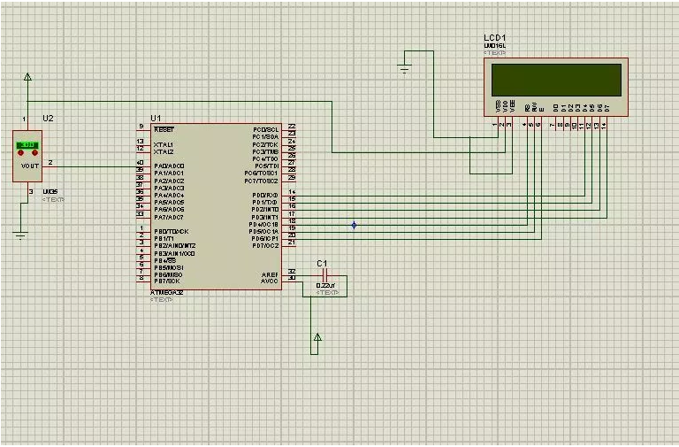

|  |  |  |  |
| --- | --- | --- | --- |
| 2. | SNAPSHOT OF THE BOARD WITH CONNECTED COMPONENTS |  |  |
|  |  |  |  |

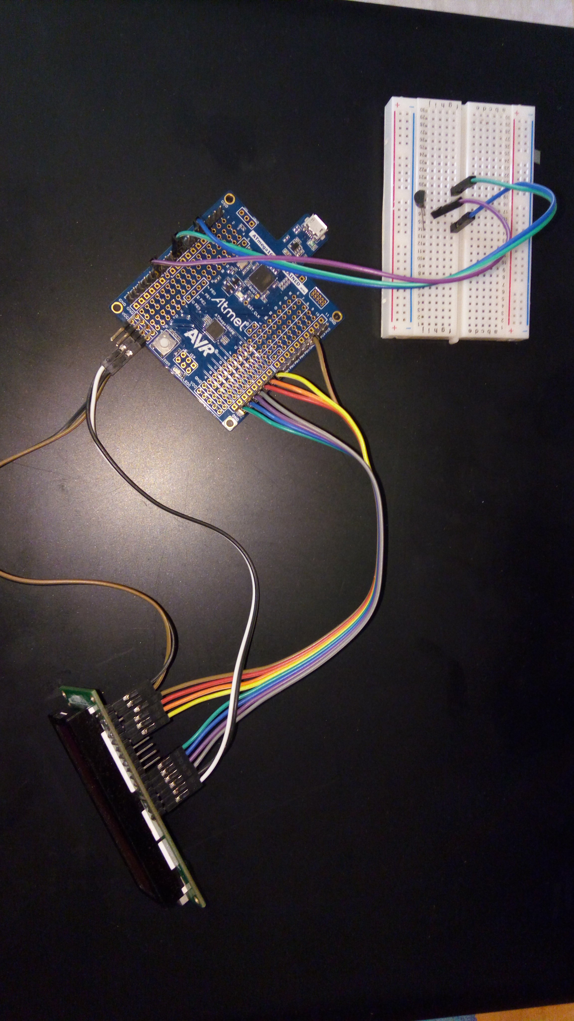

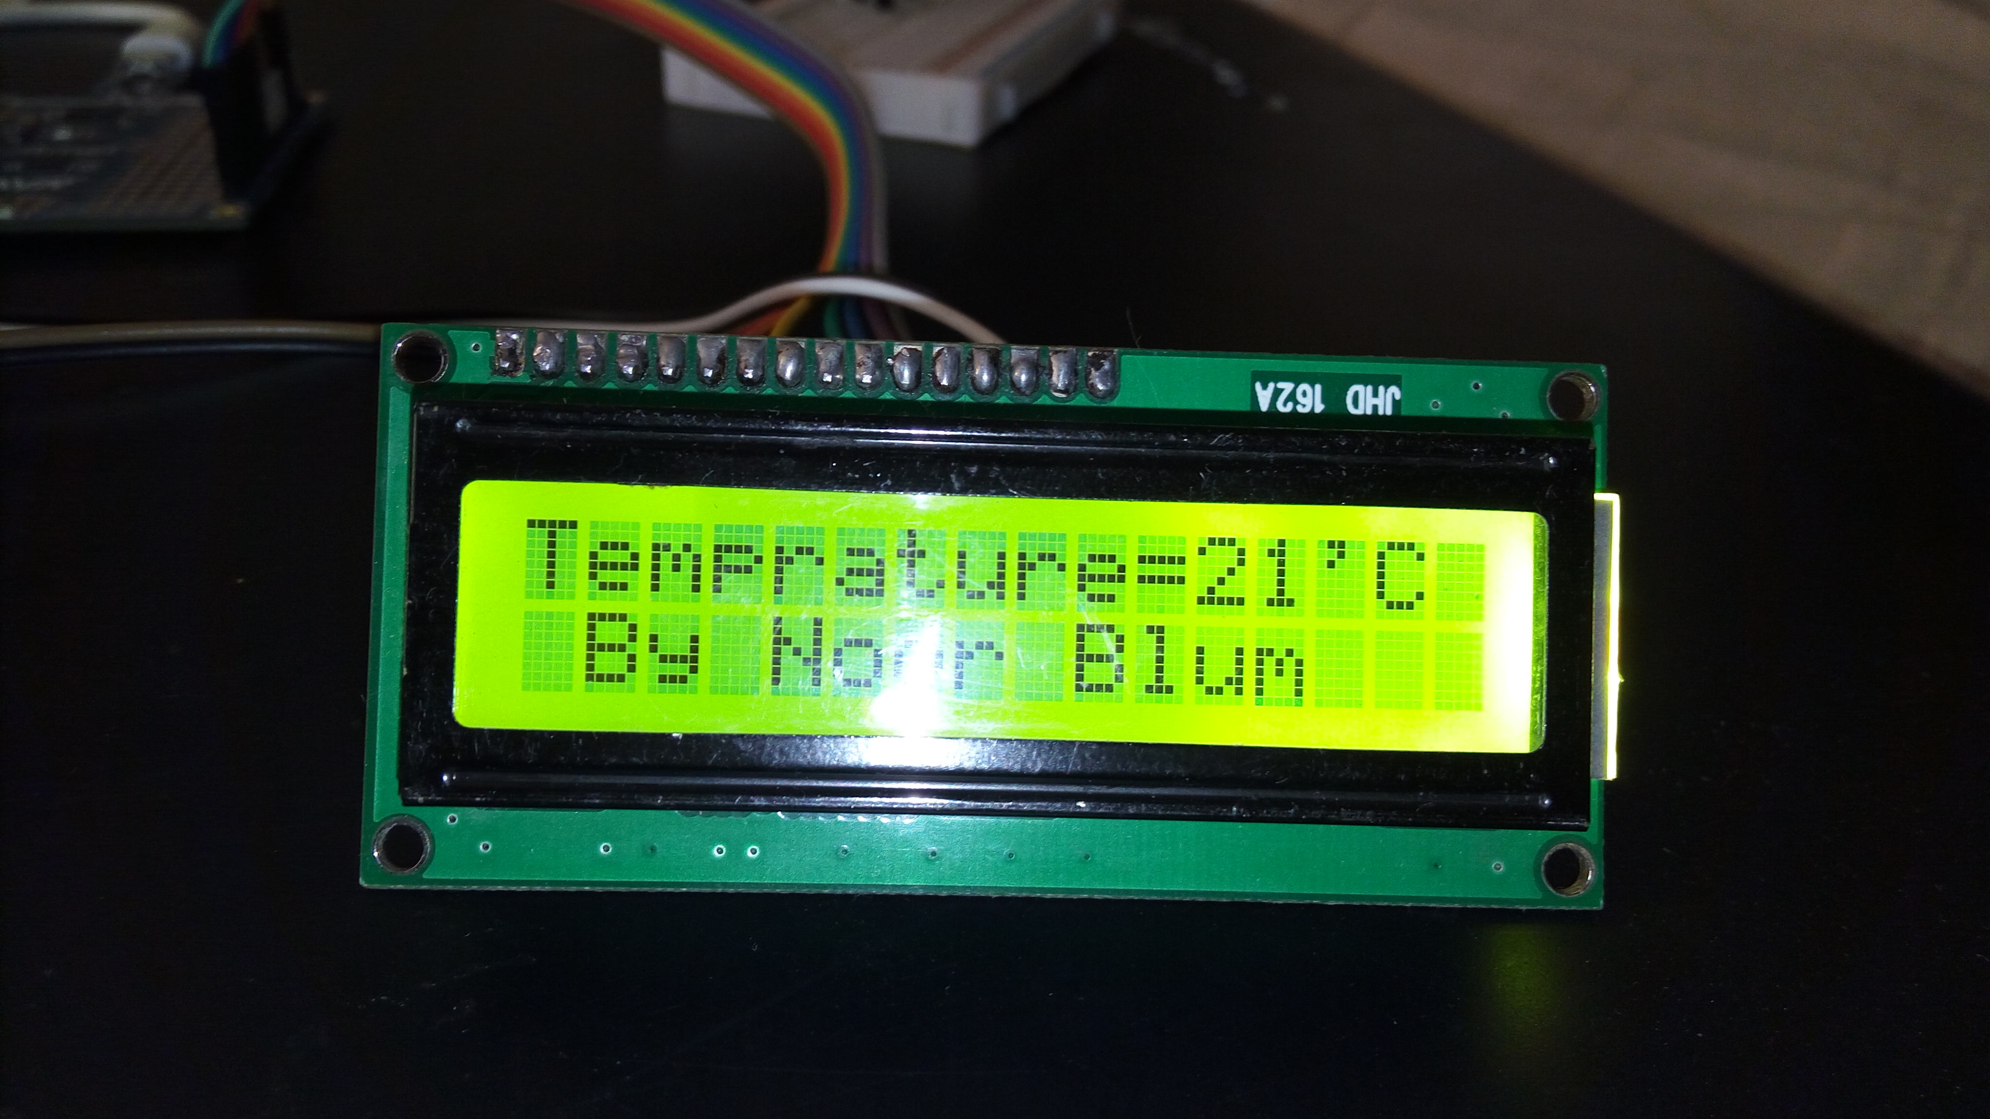

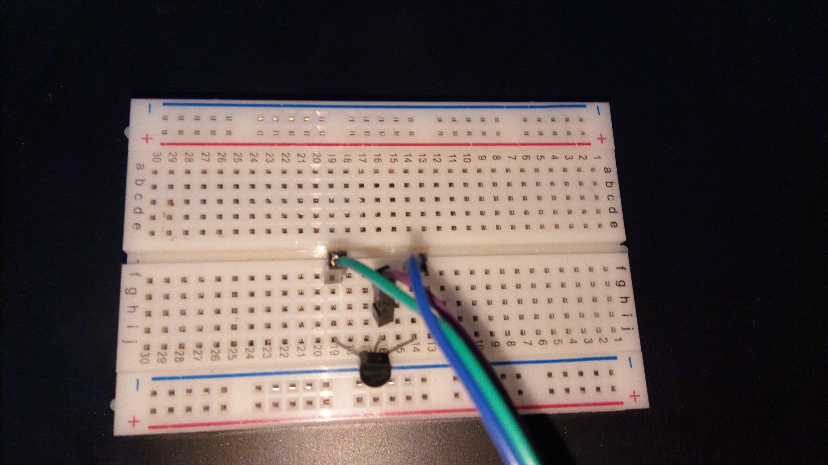

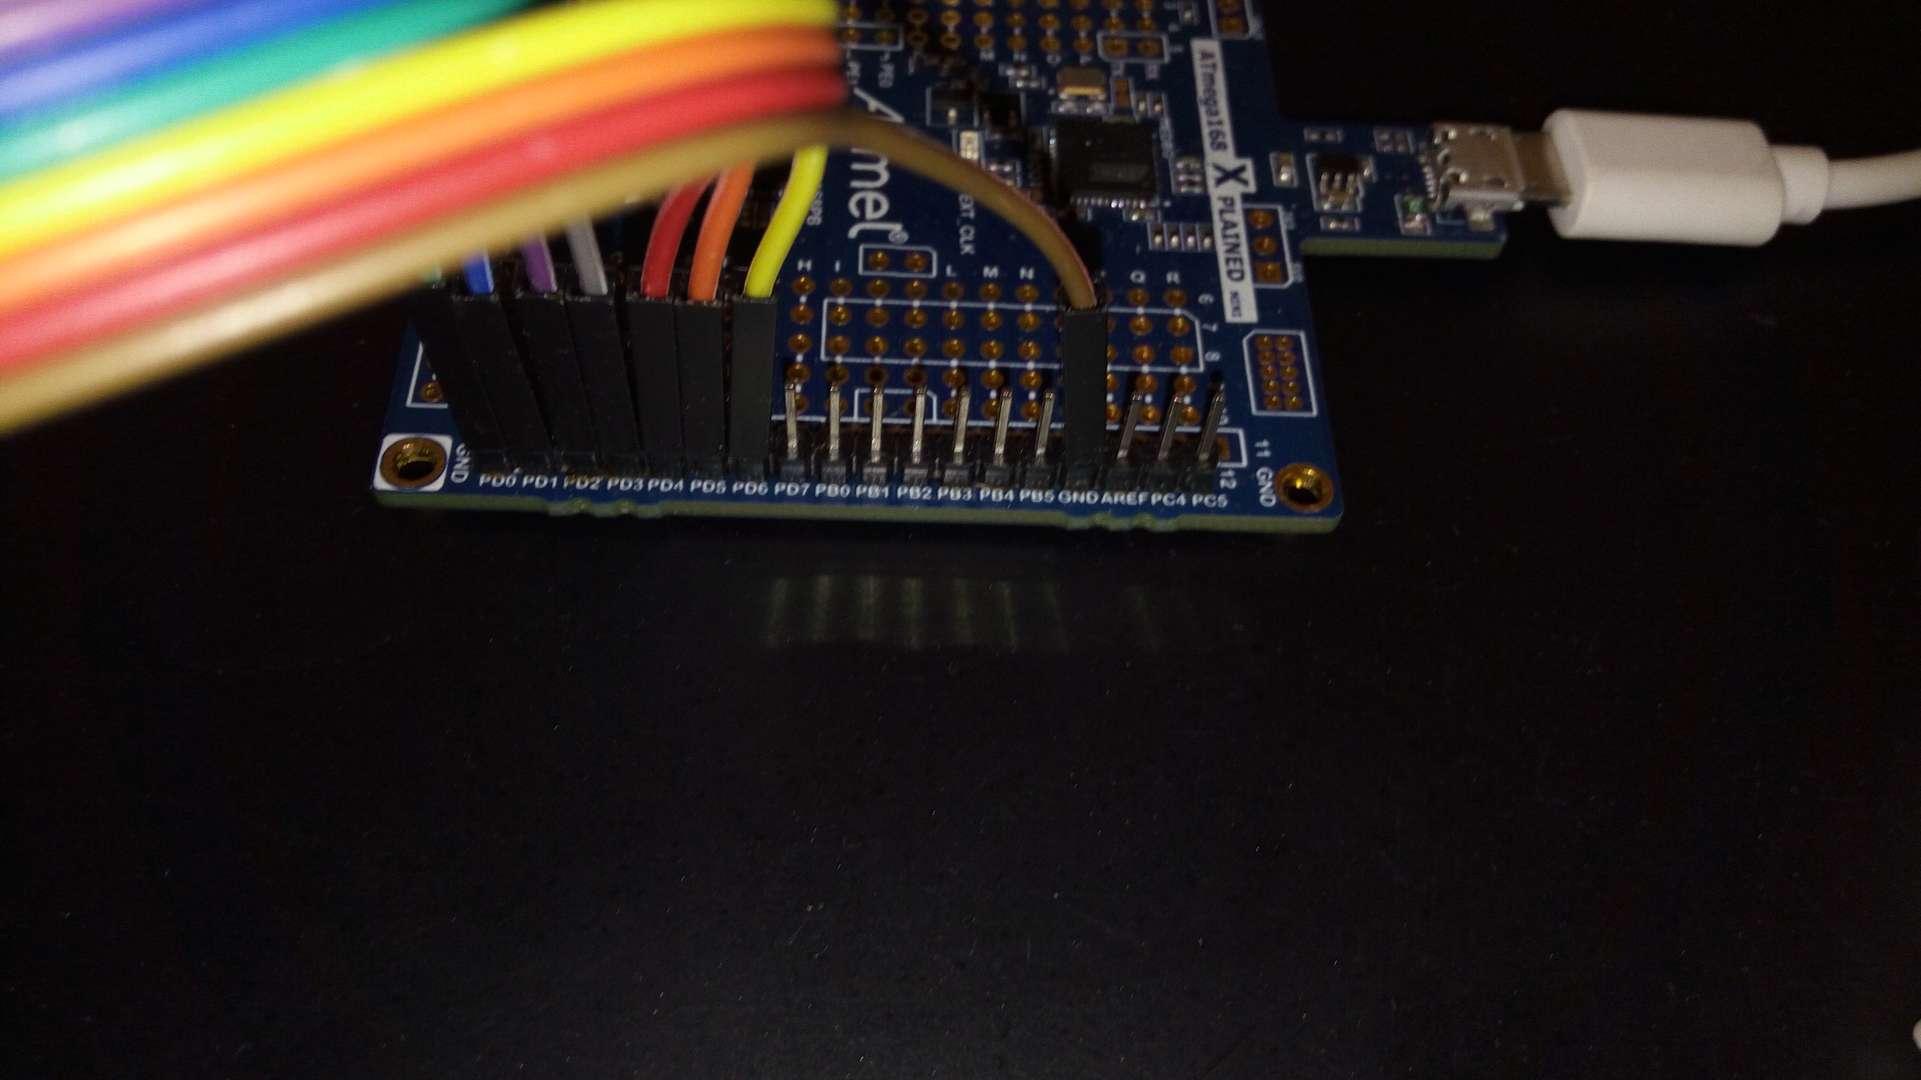

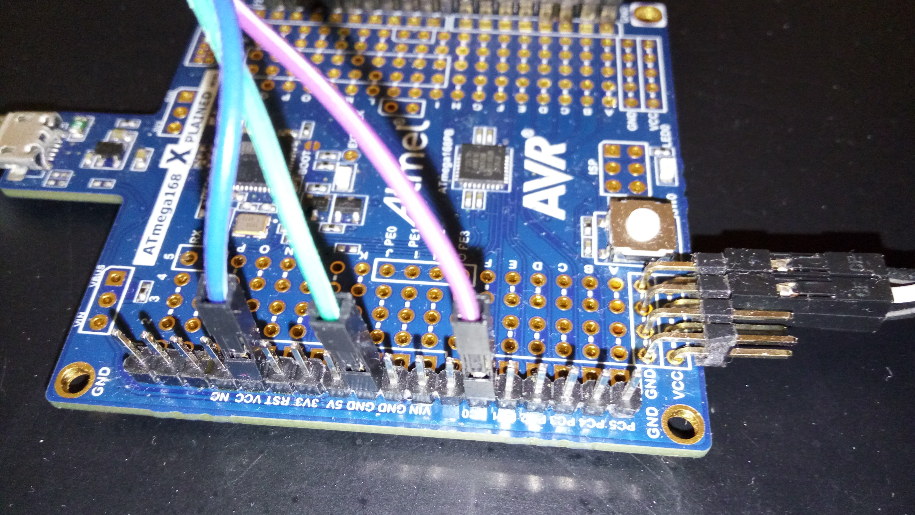

|  |  |  |  |
| --- | --- | --- | --- |
| 4. | SNAPSHOT OF THE COMPUTER SCREEN WITH TERMINAL |  |  |

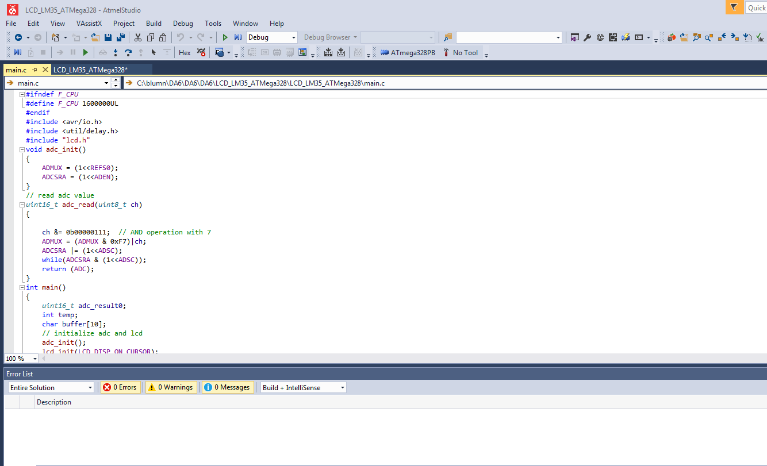

|  |  |  |  |
| --- | --- | --- | --- |
| 5. | Video Link (You tube) |  |  |

<http://www.youtube.com/watch?v=jVzBVwQW5VM>

**Student Academic Misconduct Policy**

“This assignment submission is my own, original work”.

Noor Blum